# **Unit Testing Justification Explanation**

1. testRedirect()

* Purpose : This verifies that the redirect() function sets the correct HTTP header.
* Justification: Ensures navigation works as intended when redirecting users.

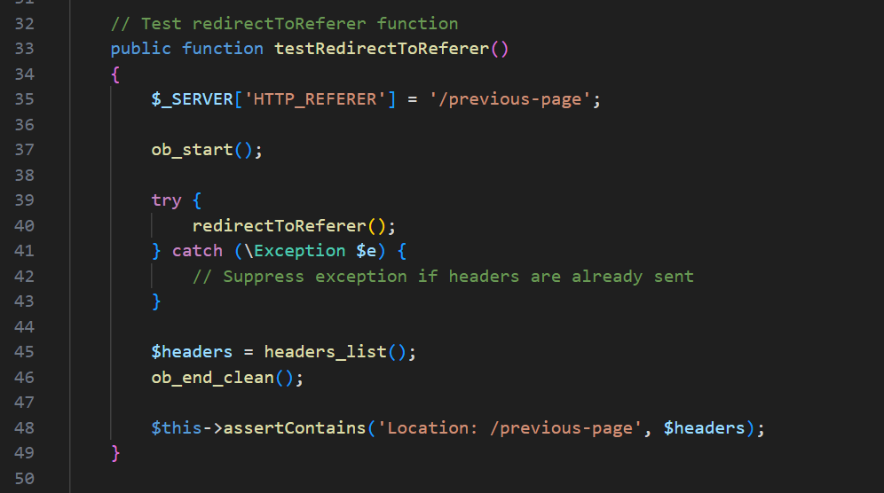

1. testRedirectToReferer()

* Purpose: Confirms the function redirects the users to the page they came from using $_SERVER[‘HTTP_REFERER’].
* Justification: Important for preserving user flow or back-navigation behaviour.

1. testFlashSetAndGet()

* Purpose: Test the settings and then begins retrieving a flash message.
* Justification: Ensures that the flash messages behave as expected--available once and then cleared (a common pattern in session messaging).

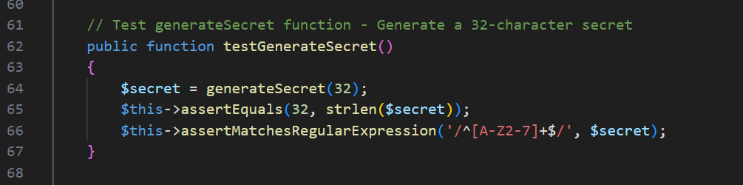

1. testGenerateSecret()

* Purpose: Verifies the generated secret is at least 32 characters long and in the correct Base32 format.
* Justification: Critical for a 2FA security – secrets must follow the TOTP standard format.

1. testGetQRCodeUrl()

* Purpose: Confirms the QR code URL is properly constructed for OTP apps like Google Authenticator.
* Checks: Presence of label, secret, and the issuer in the URL.
* Justification: Ensures interoperability with OTP apps and helps with onboarding 2FA users.

1. testVerifyCodeSuccess() and testVerifyCodeFail()

* Purpose:
* testVerifyCodeSucess(): Confirms that a valid TOTP code is accepted.
* testVerifyCodeFail(): Confirms that an invalid code is rejected.
* Justification: These are critical security tests. A valid OTP must authenticate, and invalid ones must be blocked. It also proves that the time-based tokens are functioning correctly.

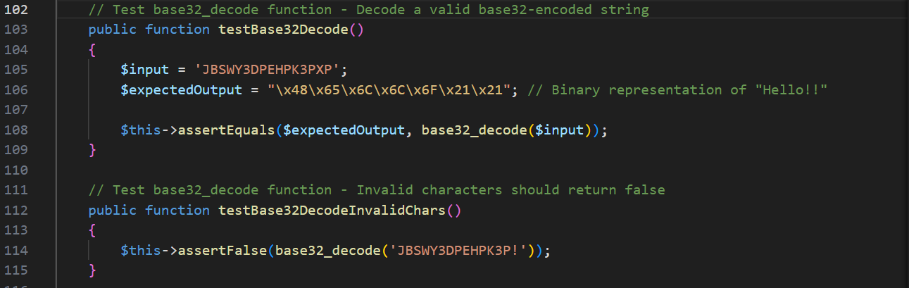

1. testBase32Decode() and testBase32DecodeInvalidChars()

* Purpose:
* testBase32Decode(): Ensures correct decoding of Base32-encoded secrets.
* testBase32DecodeInalidChars(): Ensures invalid characters return false.
* Justification: Vital for verifying encoding/decoding logic that is used in OTP operations and ensuring the integrity of user’s data.

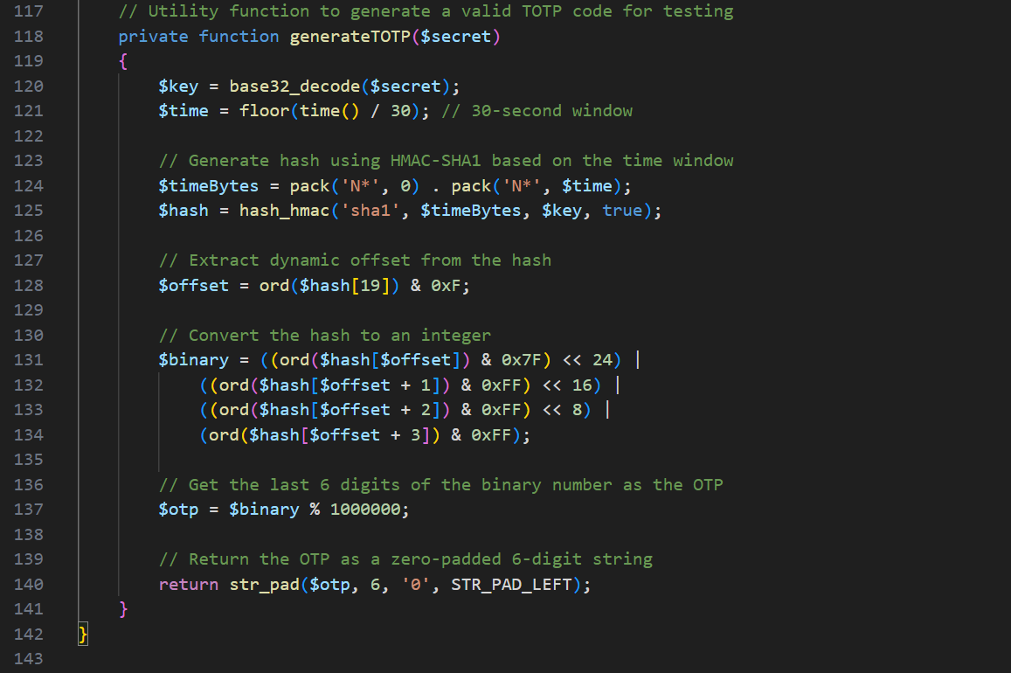

1. generateTOTP()

* Purpose: Internal helper to generate a valid TOTP based on the current time and secret.
* Justification: Enables accurate, repeatable test of the verify() function.